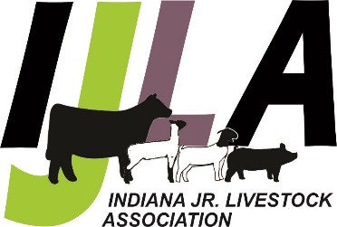
INDIANA JUNIOR LIVESTOCK ASSOCIATION
2025 Junior Board Application
Ages 14 - 21 as of January 1, 2025
Application due September 30th, 2024
Date ____________ Do you have transportation to attend meetings and events? ___________
Name ______________________________________ Birthdate ________________________
Address_____________________________________________________________________
Parents _____________________________________ Email __________________________
Phone ___________________________
Year in School __________________ School attending _______________________________
Check the species you show or have an interest in - _____ Beef _____ Boer Goat ____ Sheep ____ Swine
_____ Other (list) __________________________________________________________________
Please answer the following questions.
1. Why would you like to serve on the IJLA Board of Directors?

2. What leadership roles have you served in other organizations? Please include volunteer activities you have done as well as offices held.

3. What experience in the livestock industry has influenced you to want to be a part of the IJLA board?

4. What is an activity or program you would like IJLA to implement or improve on? It can be an original idea or something that already exists that can be improved on.
5. Check all the boxes that apply
☐Will attend 50% of the meetings – usually have 10, Zoom or in person
☐Will help with two Hoosier Elite Circuit Shows
☐Will help with at least one of the following –
1. Indiana State Fair Supreme Showmanship
2. Showman of Showmen Contest
3. Hoosier Elite Banquet
4. Santa’s Swine Showdown
Signed by ________________________
Return by September 30th to:
INDIANA JUNIOR LIVESTOCK ASSOCIATION
P.O. Box 792 - Greenfield, IN 46140
Email - injrliveassn@gmail.com

